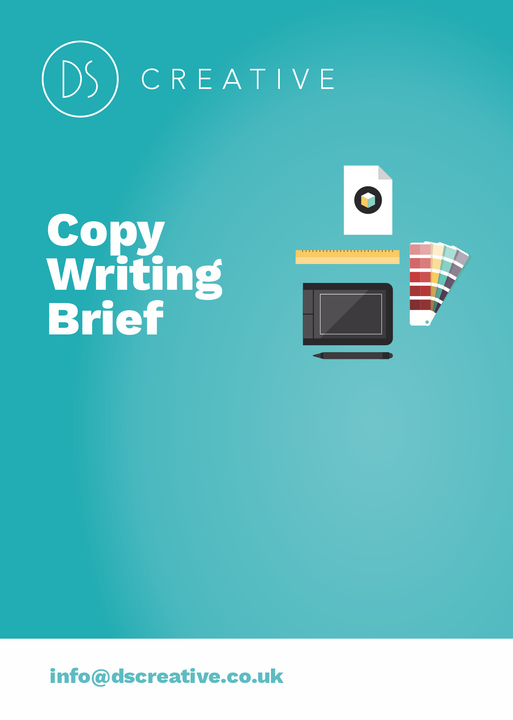
How to use this document…

- This brief is designed to get you thinking about…
  - Your business (“what you do”)
  - Your customers (“who they are”)
  - Your relationship with your customers (“how do we help them?”)
  - The sort of language we can use to get your message across.
  - What you want from your copywriting

Secondly, you don’t have to answer all the questions. You don’t have to answer them all in order.
“Why so many questions? Can’t you just figure it out?”
In short, no. You might have been doing what you do all your life. But we have no idea how your business works. Your situation is unique. These questions will help us understand exactly what you do – and how we can create copy that’s specific to you.

How long will it take?

There’s 15 questions here. The more detail you provide us, the better understanding we have of what you want. Take as long or as little as you like (but it will probably take around 30 minutes).

1. What copywriting do you require?
- Explain the type of copywriting you need from us. E.g. brochure, web page, blog post etc.

2. What is the main objective you hope to achieve with the copy?

- For example, to attract new customers, retain old customers, make your brand sound more modern, enable you to charge higher prices by positioning yourselves as a ‘premium’ product, etc.

3. Who is the audience -- who will be reading the copy? Provide as much information about the client as possible.

- For example, age, income, company size, job title, location, interests, political affiliation, choice of newspaper, gender -- anything that can help identify the reader.

- e.g. “Our clients are typically aged 30-40, have £1000 to spend, are university educated, female, interested in the arts and the environment, liberal, iPhone users, married but don’t have children, etc”

4. What content do you want?—Tell us the topic and key messages you want in the copy. Provide as much information about the client as possible.

- Key messages – Are there any key messages you need us to include? For example, specific contact details or a specific title you want etc.
  - E.g. for an article about an event these may be your key messages:
    - The date: Friday 8th June
    - The time: 10am – 5pm
    - The venue: The Valley Community Hall
    - The purpose: To bring the local community together to have a day of fun and improve community relations.
    - The activities: John Jones MP will be speaking about how the community is working to improve the local area, there’ll be activities for all the family including football, face painting and music from local bands and lots of games for small children.
    - Include the strapline ‘Working together for a better community’.

5. What tone of voice do you want the copy to have?

- Does it need to be highly education, friendly, conversational, funny, professional etc.?

6. What is the ideal word count and word limit of the copy? How many pages do you need? Provide as much information about the length as possible so we can provide you with an accurate quote.

- For example, 800 word blog post (maximum words 1000).

7. What is the primary conversion objective of the copy? What is it that you want your audience to do after receiving or interacting with this piece of communication?

- Examples:
  - Is it to buy tickets for an event?
  - Is it to visit a website to get more information?
  - Is it to buy a particular product or service?
  - Do you want your audience to sign up to your site or subscribe to your newsletter?

A bit of information about you…

1. Describe, in plain English, what your company does.

- Explain who you are first, then explain what you do. For example, “we are a factory… we are a shop… we are a website… we are a software development team…” then “we manufacture phone handsets, we develop apps for the android platform, we sell bicycles, etc”
- Avoid buzzwords or business-speak (e.g. “we provide solutions”, “we enable companies to leverage their investment and generate increased ROI” etc).

2. How do you help your clients? What benefits do you offer them? How are their lives / businesses enriched by your product / service?

- For example, “the bicycles we sell from our online shop get you from place to place faster than walking, but cost less than a car, and are better for the environment! Best of all, we deliver!”

3. What is your Unique Selling Point (USP)? (i.e. something your competitors can’t provide)

- For example, we are 50% cheaper than our nearest competitor, we have twice as many staff, all our staff have a university education, we sell our product in more colours than our competitors, our product is proven more reliable, lasts twice as long, etc.

4. Do you have any evidence to support your claims?

- Case studies, product reviews, testimonials etc.

5. Do any of your competitors provide a similar service? Who are they? What are their strengths? What does their marketing (website, brochure, etc) look like. Provide links to their websites if possible.

6. What do you like about your current copy? What don’t you want us to change?

- e.g. short, concise, headline-driven

7. What don't you like about your current copy?

- e.g. too technical, too pushy, too long, too boring, etc

8. Additional information – now we’ve got you thinking, is there anything else you think we need to know? Is there anything you definitely don’t want in the copy etc.?

