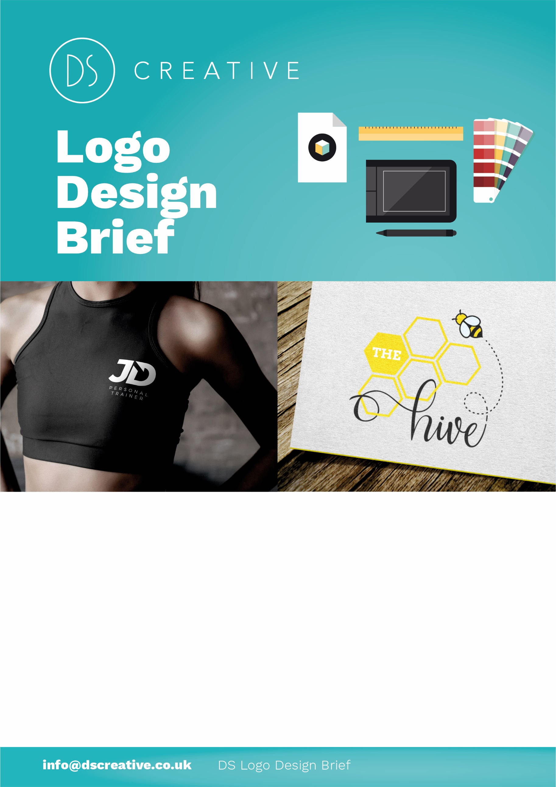

Contact Details
Company Name: Click or tap here to enter text.
Contact Name: Click or tap here to enter text.
Email: Click or tap here to enter text.
Contact Number: Click or tap here to enter text.
Business Address: Click or tap here to enter text.

1
This will give the designer an outline of what your logo requirements are. The brief is a critical part of the design process. It helps develop understanding between you and the designer - and serves as an essential point of reference for both parties. Above all, the design brief ensures that important design issues are considered and questioned before the designer starts work saving you time and money.
Please answer as many questions as you can. The more detail you can give, the more accurate your quote & design will be.

1) Logo Wording (And Tagline)
What text do you want your logo to contain? Do you have a title or company name? Does your business have an existing tagline? (E.g. “service with a smile!”)
Click or tap here to enter text.

2) Company Profile
What is your business about? What services/products do you offer? How would you describe your company? What message do you want to convey? What impact do you want to make on your customers?
Click or tap here to enter text.

3) Target Audience

Who is your target audience? Who are the types of people who need to be influenced by your logo when they see it?
Click or tap here to enter text.
4) Logo Usage
What will your logo be used for? Printed Stationary, Clothing/Embroidery, Digital Use (website, software, social media etc), Marketing Merchandise, Product Labels/Packaging etc.
Click or tap here to enter text.

5) Creative Guidelines
Is there any specific style or look you would like for your logo? Are there any specific colours you would like to use? Would you like your logo with a graphical/art element or just text? How would you like your logo to look? Classy? Modern? Fun? Traditional? Will you need more than one variation of your logo?
Click or tap here to enter text.

6) Examples of Logos/Inspiration

Are there any design examples that inspire you? What other company logos do you like?
Click or tap here to enter text.

7) Other Information

Is there anything else you would like to add to the brief? Are there any colours you do not want to include in your design? What logo designs do you dislike or want to avoid?
Click or tap here to enter text.
8) Schedule and Deadline

Do you have a deadline or specific work schedule we need to work to? Time needs to be included for research, concept, design development and production of artwork.
Click or tap here to enter text.

Once this form is complete, please either:
E-Mail it to info@dscreative.co.uk
Or mail it to / visit us at
Unit 23 President Buildings, Savile Street East, Sheffield S4 7UQ
to discuss your requirements further.
4
6

