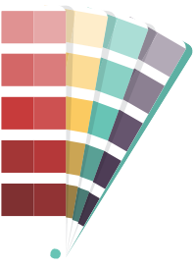
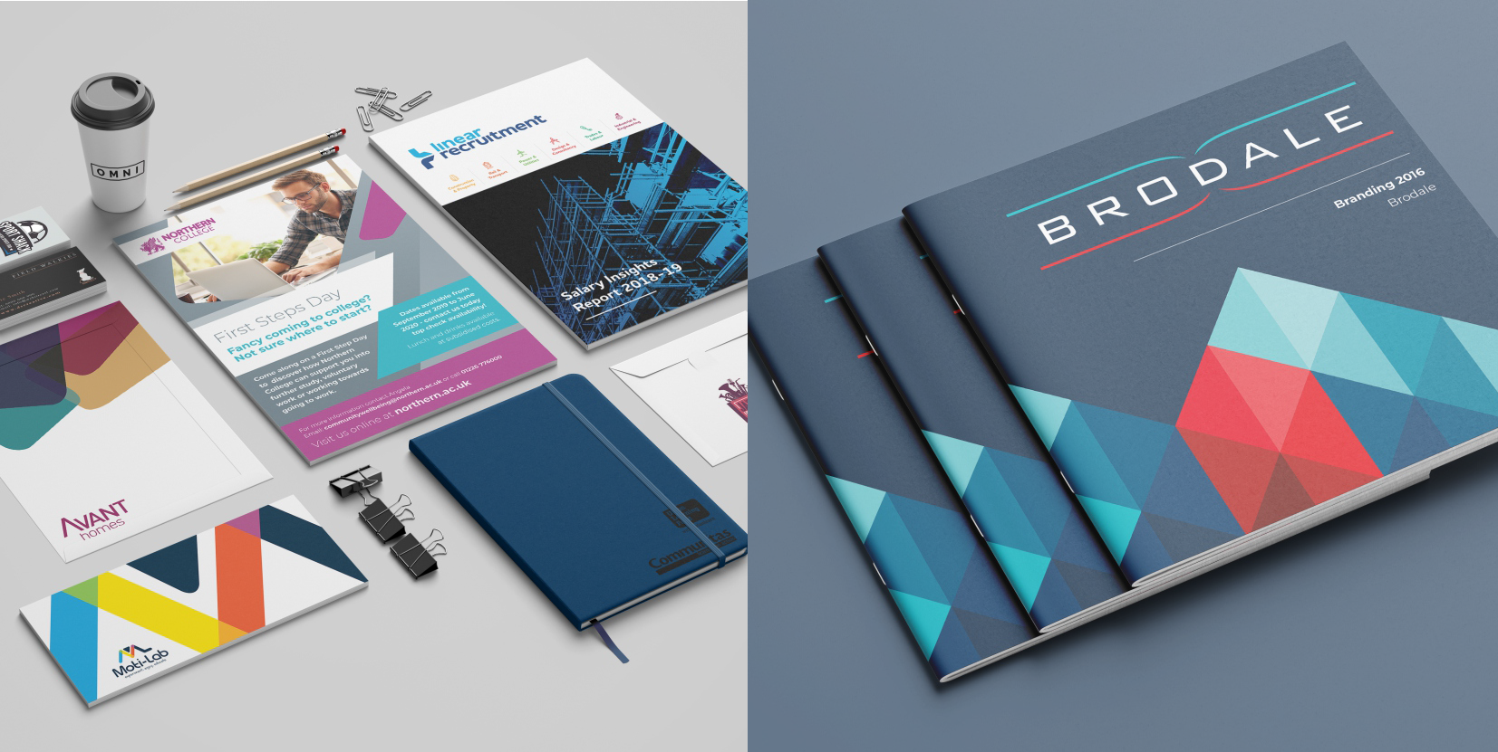
Branding Guidelines

Brief

info@dscreative.co.uk

How We Approach Branding

Discovery
1
Initial Concepts
2
Further Development
3
Concept Presentation5
4
Feedback/revisions6
5
Finalisations
6
Supply Of Brand Guidelines
7
Design Of Other Materials
8

The Brief
This will give the designer an outline of what your requirements are. The brief is a critical part of the design process. It helps develop understanding between you and the designer - and serves as an essential point of reference for both parties.
Please answer as many questions as you can. The more detail you can give, the more accurate your proposal and quote will be.
Name:
Company Name:
Email:
Phone Number:

About Your Organisation
What is your business about?

What services/products do you offer?
Insert any relevant product/service information here - why it’s different from anything else on the market. What is unique or exclusive about your products? Why do people choose your products above your competitors?

What’s the history behind your organisation?
Insert any relevant background information of company. Describe what your company does. How long have you been in business, how many employees, geographic spread, etc.

Vision & Objectives For Your Brand
What is your vision for your new brand?
What do you want your new identity to convey/communicate?

Do you have a logo/Do you require a logo design?
If you already have a logo design insert it below or specify your requirements for a new one.

Do you have a tagline/promotional message you’d like to convey through your brand?
Some companies have a tag line/catch phrase they use to promote their brand.

How will you like to apply your new brand?
What uses/purpose will your brand and identity fulﬁll? E.g. Printed materials, digital use etc

Target Audience
Who is your target audience?
Who are the types of people who need to be inﬂuenced by your brand when they see it?

Design Preferences
Describe any existing brands your logo and branding should work with.
Does the new brand need to complement existing brands (logos, font, colours) or is it a stand-alone one?

Is there any speciﬁc style or look you would like for your logo or branding?
Are there any speciﬁc colours you would like to use? Would you like your brand to include graphical/art elements or just type styles? How would you like your logo and brand to look? Classy? Modern? Traditional? Will you need more than one variation of your logo and brand?

Examples of inspiration/brands you like.
Are there any design examples that inspire you? What other company brands do you like?

Other Information
Is there anything else you would like to add to the brief? Are there any colours you do not want to include in your design? What designs do you dislike or want to avoid?

Other Materials
What other (if any) materials would you like us to create for you?

Testing
Do you plan to test your new brand?
Do you plan to test your new brand* (using surveys, focus groups, interviews, direct observation or other form of customer testing)? Over what period will testing take place?
– at the beginning, during and/or just before launch?

*If changes are required as a result of feedback from the testing, please be informed they are not part of this design project and will be quoted for and charged separately.

Schedule & Deadline
Do you have a deadline or speciﬁc work schedule we need to work to?
Time needs to be included for research, concept, design development and production of artwork.

Competitor Analysis

Who are your competitors?
Who are your main competitors in your sector? Which competitors are within a close- range to your area? Which competitors inﬂuence your company the most?

What are your competitors strengths and weaknesses?
Which aspects of your competitors impress you? What inspiration would you take from them? Which competitors are you not so impressed by? What practices do they put in place that you’d avoid?

What are your competitors main strategies?
What strategies do your competitors use that attract their target audience? What are their most successful aspects?

Why Choose Us?

OUR EXPERIENCE
We have been working with companies all over the United Kingdom for more than 14 years. With
over a decade of experience and over 1500 current clients, we have a plethora of knowledge that
we bring to every project we work on.

We boast a national client base that includes leading companies such as the NHS, HSBC, HSO and Avant Homes. Our diverse client base means that we have a wide variety of experience and are able to adapt our skills to any project.

OUR SERVICE
Providing great customer service is important to us. We are RAR recommended, meaning our services have been highly rated and reviewed by our clients. We care about our clients and we always go that extra mile to make everything just right!

OUR TEAM
Our team is made up of dedicated and friendly web designers, graphic designers and marketeers. Together, we have all the expertise, experience and knowledge to provide you with outstanding service that is of the highest quality.

OUR PASSION
Our passion separates us from other companies. We love working on projects with our clients. At DS Creative, we all enjoy what we do so we treat every project with full commitment and dedication.

OUR SKILLS
All of our team have studied and have expertise in their ﬁelds. Keeping up-to-date in the creative and technical industry is essential so we are always learning the latest trends in website development and design. At DS, we use our skills and knowledge to produce excellent websites that not only look great but work perfectly.

CONVENIENCE
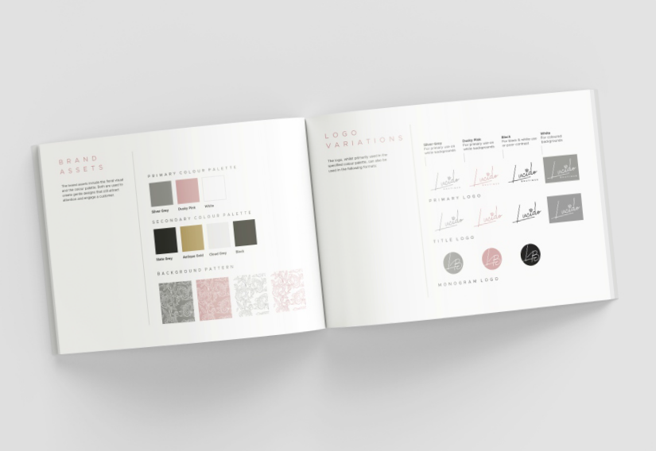
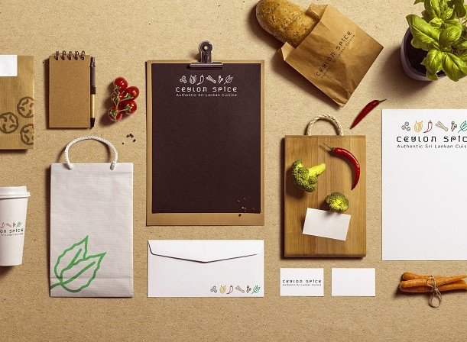
We specialise in website development, design, print and signage. We can offer you a range of expert services to help promote your company all under one roof. From the logo design to the maintenance of your website, we will be on hand to provide a seamless, efﬁcient and easy experience for you.

Thank You.

Pop us an email
info@dscreative.co.uk

Or give us a call
0114 266 9000

www.dscreative.co.uk

